Fast Food Ordering System

Quadrant One

Members:
Alena Emmanuelli
Cody Howell
Jayden Patton
Kenny Lee
Taying Yang
Kyle Burchett

Project Description

Overview
The fast food ordering system is an application designed to make ordering and the management process more efficient and organized for both the customer and restaurant staff. The application brings all ordering features onto one user friendly interface. The system allows customers to place food orders through a single application where they can also track the progress of their order and choose between a selection of menu items. For the restaurant staff they are able to view all incoming orders, update customer order statuses, manage the menu items, and assign orders to either delivery or pickup based on the customers request. This application will provide a more efficient and easy experience for both the customer and restaurant staff.

User Interface
An online portal for orders ← can be done using CSS/HTML for the web design of the single portal. Depending on the team, we will most likely use JavaScript to make the website work. The way it should work, based on the description, is to have an online portal for orders, have specific tabs such as menu and trackers for when placing orders, make their own choices, and after placing orders, they/we can track their progress. The progress should also help as a resource to help workers maintain their work speed.

Landing Page
The landing page will be the page that customers and staff are sent to first, introducing them to the application through an organized layout (probably a navigation bar) that encourages easy navigation and quick interaction. From the landing page, staff should be able to login, sending them to the Employee Dashboard, while customers are able to view the menu, begin placing an order, access deals, or access order tracking features. Selecting a menu item from the landing page will start the ordering process, bringing users to where additional customization features will be present. The page should be designed with accessibility in mind, ensuring that the page provides a fluent experience for all users. Landing page design should focus on highlighting Deals and “HOT” items to attract attention, increase customer engagement, and provide help overall.

Menu
A page that displays the current and available food items for the restaurant. Listed with prices and may include applicable Deals to grab customer attention. Allows the user to add items to their “cart”.

View Cart
A transition page between Menu and Place Order. Shows what the customer currently has in their cart, and allows them to remove or add items. This page also shows the cumulative price of the items in the order, plus a tax multiplier. Has an option to “Continue to Order” if the customer is ready to proceed with the purchase.

Place/Track Order
The final page the customer is sent to after viewing their cart. Allows the user to input their credentials and finally send the actual order to the Employee side, first checking Inventory. If the order goes through successfully, the order is put into the Order Manager (visible only for Employees), and the order will be visibly tracked from the customer side on this same page. They will receive updates such as “order successfully received”, “preparing order”, and “order is ready”. These updates are sent live from the Employee’s Order Manager, listed below.

Login Page
Employees have the option to log in from the Landing Page. This will just be a classic login page, with textboxes for username and password. Successful login grants access to the Employee Dashboard. Inputs should require a valid email format for the username, and the password should meet predefined requirements to ensure authentication. Guests are not required to login. Only staff are required to login, allowing them to be able to conditionally access and view the employee dashboard. Navigation to this page should be visible from most or all pages so that employee users are aware if they are logged in or not. (Example: The login button will render as “Hey User! Log out.” when the employee is currently logged in.)

Employee Dashboard
The page that first appears after using the Login Page. Shows options such as Inventory Tracker, Order Manager, (unfinished)

Inventory Tracker
The inventory tracker automatically updates item quantities when orders are placed to keep menu availability accurate. It is implemented using backend API endpoints written in either Python or Javascript with fastAPI, which handles inventory checks and updates. Inventory data is stored and managed in a database, which we can use something like MySQL for, and the frontend retrieves inventory status through API calls to ensure unavailable items are not shown to users.

Order Manager
The order manager keeps track of customer orders from when they are placed until they are completed. Restaurant staff can see new orders and update their statuses using backend APIs written in Python or Javascript with fastAPI. All order data is stored in a database in which we can use MySQL for. The frontend uses API calls to show real time order updates which will ensure both the staff and customers are able to stay informed and keeps the ordering process organized.

Template for custom features:
→ custom features + descriptions here
- An example showed the page description as well
- custom feature 1. That we see everywhere should be the “Deals” and “ family meals” and “HOT” ← , aka popular foods or most bought, etc. This should be on the front page of the online portal, as it will attract customers to certain orders, and this will help recommend things for people that are trying for the first time.
- custom feature 2: Order Customization Panel: Allows users to fully customize their meals/orders before adding them to cart with the options of size, sides, toppings, sauces, drink choice will be displayed … user selects menu item —> a pop up appears for customization options such as: “Extra cheese” “Remove mayo”, “Small/Medium/Large”
- Custom feature 3: Order Tracker: Allows customers to view the status of their order after checkout. Ex: order placed, preparing, ready, completed. Status icons update automatically and can be seen by the kitchen staff
- Custom feature 4: Accessibility Features: accessibility designed features to make sure the application use is simple for users. Ex: simple navigation, keyboard controls, high contrast colors
- Custom feature 5: Employee login system: application includes an employee-only login feature allowing staff to access orders internally and a management interface. Ex: username field, password field, login button, error message for invalid login attempts
→ include info about:
- intended release platform(s)
- backend info
- frontend info
- database usage if applicable

Risk Management
Team member losing access to wifi or their device
- Probability: Low
- Impact: Low; If this happens, the impacted team member should have other options to access the project online
- Monitoring: Members should make sure to stay on top of their designated task due dates, which gives extra time to do their work in case of losing their device power, as well as pay attention to the weather.
- Mitigation: Members should find additional ways to access the internet in case of an issue, such as using cellular data or going to a different location.

Communication issues and missed deadlines
- Probability: low
- Impact: High, late submissions will negatively impact the project grade
- Monitoring: Consistent communication and have reminders for all group members to make sure everyone is getting their fair share done
- Mitigation: Weekly meetings to check in and split up the work equally so one person does not get overwhelmed with work

Unfamiliar softwares
- Probability: Medium
- Impact: Critical
- Monitoring: This project should be built in such a way that at least one person is proficient at each software chosen to help create it. Consistent communication and confirmation on how things will be done will help prevent this issue.
- Mitigation: This risk must be prevented before getting too deep into the project. Once the project schedule reaches a certain point, the choices will most likely be irreversible.

Project Schedule

Milestones and Timeline
(can be changed, took points from Canvas example)
Consensus on Details → Wed, Feb 4, 2026
Delegate Roles → Fri, Feb 6, 2026
Document UI design → Fri, Feb 20, 2026
Final Mockups → Fri, Mar 6, 2026
Core Functionality completed → Fri, Mar 20, 2026
Remaining Features completed → Fri, Mar 27, 2026
System Integration completed → Fri, Apr 3, 2026
Testing completed → Fri, Apr 10, 2026
Adjustment/Editing period → Fri, Apr 17, 2026
Project complete → Fri, Apr 24, 2026

Charts

PERT
<chart here>

Gantt
Quadrant One - Gantt Chart

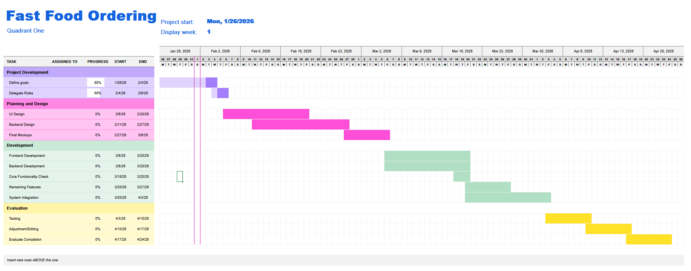

Team Contributions
Member Name | Contribution Description | Overall Contribution (%) | Notes
Kenny Lee | Project description, Risk Management | 16.67%
Cody Howell | Milestones/Timeline  Landing Page & Login page description | 16.67%
Alena Emmanuelli | Risk Management 2x, User Interface descriptions | 16.67%
Kyle Burchett | Chart Creation | 16.67%
Jayden Patton | Custom Features | 16.67%
Taying Yang | Custom Feature / UI | 16.67%

